**Assessment 2C: Image comparison code workbook**

Nikki Fitzherbert jc697513

Comparison between all images

Perfect similarity scores are expected for the pairs comparing themselves. The two apple images received a relatively high similarity score of 0.7125 according to the *compareImages* function and the two hammer images should receive a similar value.

Below is the complete predicted order of image pairs from highest to lowest similarity. Note that there are only 55 pairs as it did not matter which order the pair was in. For example, the similarity score for Hat-Teddy was the same as the similarity score for Teddy-Hat.:

|  |
| --- |
| Glass-Glass |
| Heart-Heart |
| Apple_13-Apple_13 |
| Apple_9-Apple_9 |
| Hammer_12-Hammer_12 |
| Hammer_4-Hammer_4 |
| Hat-Hat |
| Imfish-Imfish |
| Spring-Spring |
| Teddy-Teddy |
| Hammer_12-Hammer_4 |
| Apple_13-Apple_9 |
| Glass-Hat |
| Heart-Apple_13 |
| Heart-Apple_9 |
| Imfish-Teddy |
| Heart-Hammer_4 |
| Heart-Hammer_12 |
| Apple_9-Hat |
| Apple_13-Hat |
| Hammer_12-Imfish |
| Hammer_12-Teddy |
| Glass-Hammer_4 |
| Hammer_4-Imfish |
| Hammer_4-Teddy |
| Glass-Hammer_12 |
| Hat-Teddy |

|  |
| --- |
| Apple_9-Teddy |
| Apple_13-Teddy |
| Glass-Teddy |
| Spring-Teddy |
| Imfish-Spring |
| Glass-Heart |
| Glass-Apple_9 |
| Apple_9-Hammer_4 |
| Hammer_4-Hat |
| Glass-Apple_13 |
| Apple_13-Hammer_4 |
| Apple_9-Hammer_12 |
| Hammer_12-Hat |
| Heart-Hat |
| Heart-Teddy |
| Apple_13-Hammer_12 |
| Hat-Imfish |
| Hat-Spring |
| Glass-Spring |
| Heart-Spring |
| Hammer_4-Spring |
| Hammer_12-Spring |
| Apple_9-Spring |
| Glass-Imfish |
| Heart-Imfish |
| Apple_13-Imfish |
| Apple_13-Spring |
| Apple_9-Imfish |

%% Mass comparison

% We can now compare all of the test images to one another.

% We first obtain the full file list

filelist = dir('*.png')

N = length(filelist)

% filenames = {}

for i = 1:length(filelist)

filenames{i} = filelist(i).name;

end

% We will store each comparison into a matrix, so that each row/column

% corresponds to a particular image.

mat = zeros(N);

% We now loop over all of the files twice, so that we go through each

% element of the matrix.

for iA = 1:N

fileA = filelist(iA);

imA = imread(fileA.name);

for iB = iA:N

fileB = filelist(iB);

imB = imread(fileB.name);

val = compareImages(imA,imB);

mat(iA,iB) = val;

mat(iB,iA) = mat(iA,iB);

end

end

%% Mass comparison results

% After obtaining the comparison between all of the images, we can plot

% this.

imagesc(mat)

colorbar

% We also output all of the filenames and their corresponding number.

for i = 1:N

disp(['i = ', num2str(i), ' is ', filelist(i).name])

end

i = 1 is Glas-1.png

i = 2 is Heart-2.png

i = 3 is apple-13.png

i = 4 is apple-9.png

i = 5 is hammer-12.png

i = 6 is hammer-4.png

i = 7 is hat-19.png

i = 8 is lmfish-11.png

i = 9 is spring-9.png

i = 10 is teddy-04.png

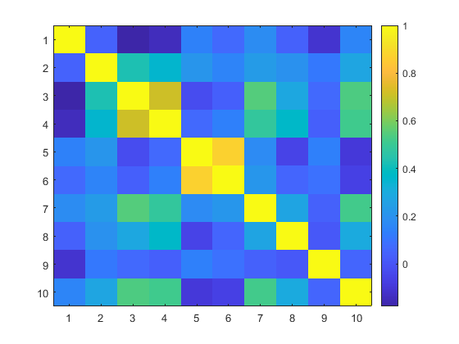

The array is symmetric across the diagonal, which shows the (perfect) similarity scores of the images compared to themselves. Therefore, the discussion of the patterns in the scores will concentrate on the lower half. There are also two other lighter squares that indicate the high similarities of the two apple images and two hammer images as was expected. The majority of the rest of the array received relatively low similarity scores except for three images paired with the teddy bear image (image/row 10), two with the hat (image/row 7) and the heart-apple-13 (image/row 13).

The patterns displayed are mostly as expected, except the high similarity scores for the teddy-apple pairs , and the apple_9-imfish pair was a surprise. On the opposite on of the spectrum, the low similarity scores for such pairings as the hammers-teddy and glass-hat were also unexpected.